LGBM & XGBM

* **A brief report summarizing the comparative analysis results and practical implications.**

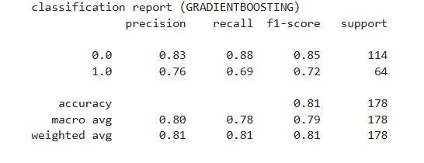

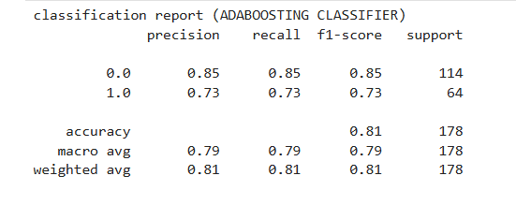

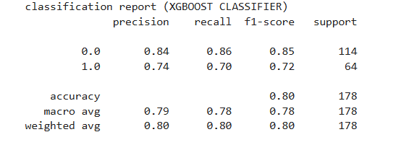

**Comparative analysis** **of Boosting Methods and Practical Implications:**

1. **Gradient Boosting**

* **Strengths**:
  + High recall for class 0.0 (88%) indicates it is effective at identifying the majority class.
  + Balanced precision and recall lead to a strong F1-score for class 0.0 (85%).
  + Slightly lower recall for class 1.0 (69%) indicates some difficulty in capturing the minority class.
* **Practical Implications**:
  + Suitable for applications where identifying the majority class is crucial (e.g., fraud detection where false negatives in minority class are acceptable).

1. **AdaBoosting**

* **Strengths**:
  + More balanced recall between classes (both at ~73%).
  + F1-score for class 1.0 (73%) is the highest among the three methods.
* **Limitations**:
  + Precision for the minority class (1.0) is slightly lower (73%) compared to Gradient Boosting.
* **Practical Implications**:
  + A better choice in scenarios where class balance is important, such as medical diagnostics where both false positives and false negatives must be minimized.

1. **XGBoost**

* **Strengths**:
  + High recall for class 0.0 (86%), comparable to Gradient Boosting.
  + Precision for class 0.0 (84%) is strong, slightly outperforming Gradient Boosting.
* **Limitations**:
  + Slightly lower F1-score for class 1.0 (72%) and macro-average F1-score (78%).
* **Practical Implications**:
  + Works well for larger datasets or when computational efficiency is important due to its speed and parallelization capabilities.

**Summary**

* **Gradient Boosting** excels in precision and recall for the majority class but struggles slightly with the minority class.
* **AdaBoosting** provides the most balanced performance between the two classes, making it ideal for imbalanced datasets.
* **XGBoost** offers a trade-off between computational efficiency and performance, performing well for the majority class while being slightly less effective for the minority class.